



**General Practice/  
Family Practice RefSet and ICPC mapping project**

User guide for participants

**Field test**

Date: 26th September 2013

**Table of Contents**

1 Introduction 5

2 Background 5

3 Purpose 6

4 Audience 6

5 Data collection 6

6 Field test website 7

7 Specification requirements 7

8 Registration 7

9 Starting the field test 9

9.1 Log in 9

9.2 Log out 9

10 Home page 10

11 Encounters 10

12 Reason for Encounter (RFE) 11

13 Health Issue (HI) 11

14 Field test of GP/FP RefSet only 12

14.1 Add Reason for Encounter 12

14.2 Rate appropriateness of the concept 13

14.3 Add Health Issue 14

14.4 Rate appropriateness of the concept 14

15 Field test of GP/FP RefSet and map to ICPC-2 16

15.1 Add Reason for Encounter 16

15.2 Rate appropriateness of the concept 17

15.3 Select and rate the map to ICPC-2 17

15.4 Appropriate map to ICPC-2 17

15.5 Inappropriate map to ICPC-2 18

15.6 Add Health Issue 19

15.7 Rate appropriateness of the concept 19

15.8 Select and rate the map to ICPC-2 19

15.9 Appropriate map to ICPC-2 20

15.10 Inappropriate map to ICPC-2 20

16 Field test of ICPC-2 map to GP/FP RefSet 23

16.1 Add Reason for Encounter 23

16.2 Rate appropriateness of the concept 24

16.3 Add Health Issue 26

16.4 Rate appropriateness of the concept 26

17 Review encounters 28

17.1 Editing an encounter 29

18 Delete encounters 29

19 Submit encounters 30

20 Questions and feedback 30

1. Introduction

SNOMED CT is an international clinical terminology. It contains over 300,000 clinical concepts and is designed for use within electronic medical records. The International Health Terminology Standards Development Organisation (IHTSDO) owns SNOMED CT and is responsible for its development and maintenance. There are 23 Member countries involved in the development of SNOMED CT. More information about the IHTSDO and SNOMED CT are available from http://www.ihtsdo.org/

The use of standardised clinical terminologies such as SNOMED CT facilitates the recording of clinical information in a reliable, consistent and unambiguous manner and subsequently promotes sharing such information and data.

1. Background

In December 2009 the IHTSDO and World Organisation of Family Doctors (Wonca) signed an agreement to promote co-operation and collaboration between the two organisations. The agreement led to the formation of the International Family Physician/General Practitioner Special Interest Group under the auspices of the IHTSDO.

As part of the agreement a program of work was established to develop two products:

- A small subset of SNOMED CT concepts commonly used in general practice/family practice internationally (known as the general/family practice reference set or GP/FP RefSet)

- A map (or link) between concepts in the GP/FP RefSet to the International Classification of Primary Care, Version 2 (ICPC-2).

The work program is being conducted by a team at the University of Sydney, overseen by a Project Group made up of GPs/FPs from six countries.

The GP/FP RefSet has been constructed by collecting actual "grass roots" general/family practice terms from seven countries around the world, amalgamating all the terms received into a single list of general/family practice terms, and determining the most commonly used terms on an international level based on term frequency.

SNOMED CT contains approximately 300,000 concepts in its entirety. In contrast, the GP/FP RefSet contains approximately 4,000 SNOMED CT concepts that are commonly used as either reasons for encounter (RFEs) or health issues (HIs) in general/family practice. When fully implemented GPs/FPs can use the RefSet as an entry point to SNOMED CT, where SNOMED CT concepts that are not present in the GP/FP RefSet could be assessed by conducting a secondary search of the remaining content.

The development of the RefSets and the map to ICPC-2 is now complete and the two products need to be field tested prior to their implementation.

During the field test, participants will only assess SNOMED CT concepts in the GP/FP RefSet. These concepts represent only a portion of SNOMED CT, and participants will not be able to view or assess SNOMED CT in its entirety.

It must be emphasised that these RefSets are designed for use internationally. As a result, some content that is specific to a particular country may not be present in the RefSets. It is envisaged that additions will be made to the GP/FP RefSets on a national level to match local needs.

1. Purpose

The aims of the field test are:

- To assess the completeness of the GP/FP RefSet

- To identify important missing content in the GP/FP RefSet

- To assess the accuracy of the map from the GP/FP RefSet to ICPC-2

1. Audience

GPs/FPs who are actively working in general/family practice are asked to participate in the field test. No prior knowledge of SNOMED CT or ICPC-2 is required for participation.

This user guide is intended for GPs/FPs who have agreed to participate in the field test of the GP/FP RefSet. Participants can choose to field test the GP/FP RefSet only, the GP/FP RefSet and map to ICPC-2, or the ICPC-2 map to RefSet. This user guide contains instructions for each field test option.

1. Data collection

Basic demographic details about participants will be requested during registration for the field test. No identifying information about patients is collected. Only data about reasons for encounter and health issues are being collected.

The field test website is hosted on a secure server. The personal information of participants and the data collected about encounters with general practice patients will only be used within the scope of this project and not be supplied to third parties.

1. Field test website

The field test is being conducted using a web-based tool designed specifically for the field test. The web interface for the field test can be accessed from the following link: http://fieldtest.snomedtools.com

It is recommended that you bookmark the URL for the field test website as you are likely to access the field test website on several occasions.

1. Specification requirements

As the field test tool is a browser based application, the minimum internet browser specifications required are:

* Internet Explorer v8+
* Firefox v17
* Chrome v23
* Safari v5.1

If you experience any technical issues during the field test, please contact your local Project Group member. Their contact details can be found in the recruitment letter. Alternatively, email the project manager, Julie O'Halloran (julie.ohalloran@sydney.edu.au).

A Google Group has also been set up for participants to ask questions and share feedback. All questions will be answered by a member of the Project Group. You can access the Google Group by clicking [here](https://groups.google.com/forum/?hl=en#!forum/ihtsdo-wonca-field-test) or go to <groups.google.com>and search for 'GP/FP RefSet'. You will need to log in to your Google account before you can post a question.

1. Registration

In order to participate in the field test, you need to register your details to create an account.

1. Open your internet browser and go to http://fieldtest.snomedtools.com
2. On the homepage under the heading 'New users', click on 'Click here to register'.
3. Fill in your details on the participant registration form. All fields need to be completed and a valid email address needs to be supplied in order to register for the field test. Note that the password you select must be at least 6 characters long and the field is case sensitive.

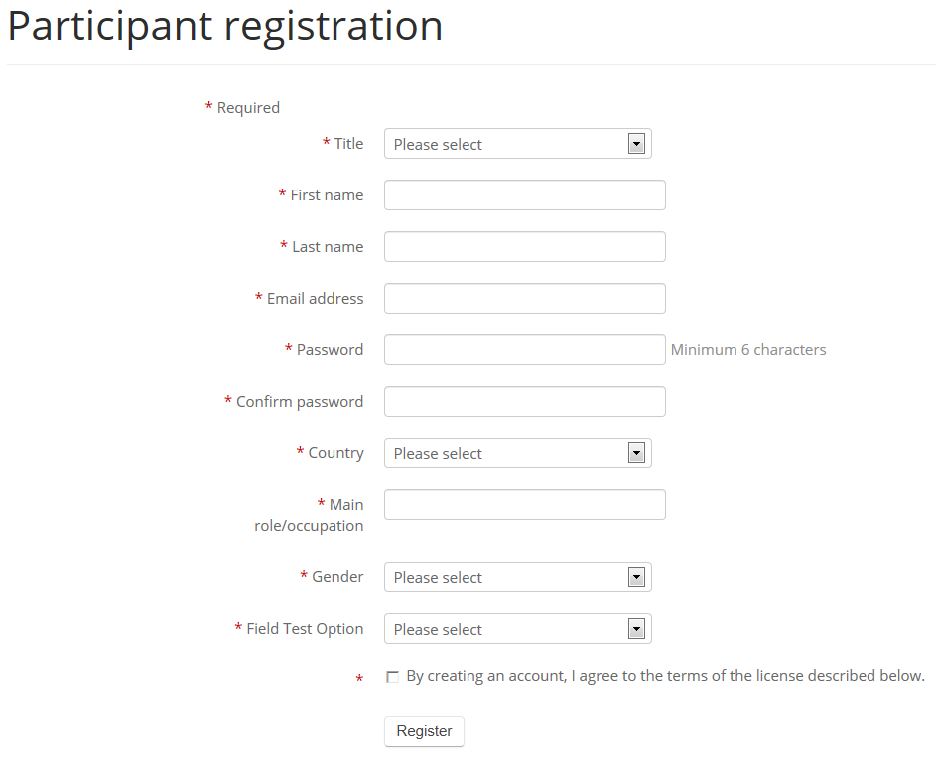

1. Select the field test option you want to participate in.

An email address can only be registered once for the field test and you can only participate in one field test option using that email address. If you want to participate in the other field test options, you will need to complete the registration form again using a different email address. Participants who do not use ICPC-2 in their practice can opt to test the SNOMED CT RefSet alone.

1. Read the Terms of Agreement and click on the tick box to indicate 'By creating an account, I agree to the terms of the license described below'.
2. Click 'Register'.

An email containing a verification code will now be sent to the email address you supplied. The email will be sent from the email address: fieldtesttool@ihtsdo.org, with the subject: SNOMED CT Field Test Website - Registration

1. You will need to confirm your registration by copying the verification code from the email into the verification code field on the registration confirmation webpage (http://fieldtest.snomedtools.com/verify.php). You can choose to manually enter the verification code. Note that the verification code is case sensitive.

If you do not receive a verification email, check that the correct email address has been entered. If the email address is incorrect you will need to register again with the correct email address. If it is correct, click on 'Resend verification code' and check your junk email folder as it may have been directed there instead of your inbox. If problems continue, please contact your local Project Group member.

1. Once verification is successful, click 'Home'. Then click 'Home' again.

You can view your profile information by clicking on your name in top right corner and clicking on 'Profile'. You can edit your information and change your password from the Profile page.

1. Starting the field test

9.1 Log in

After completing the registration process, you will already be logged in and can immediately start entering encounters.

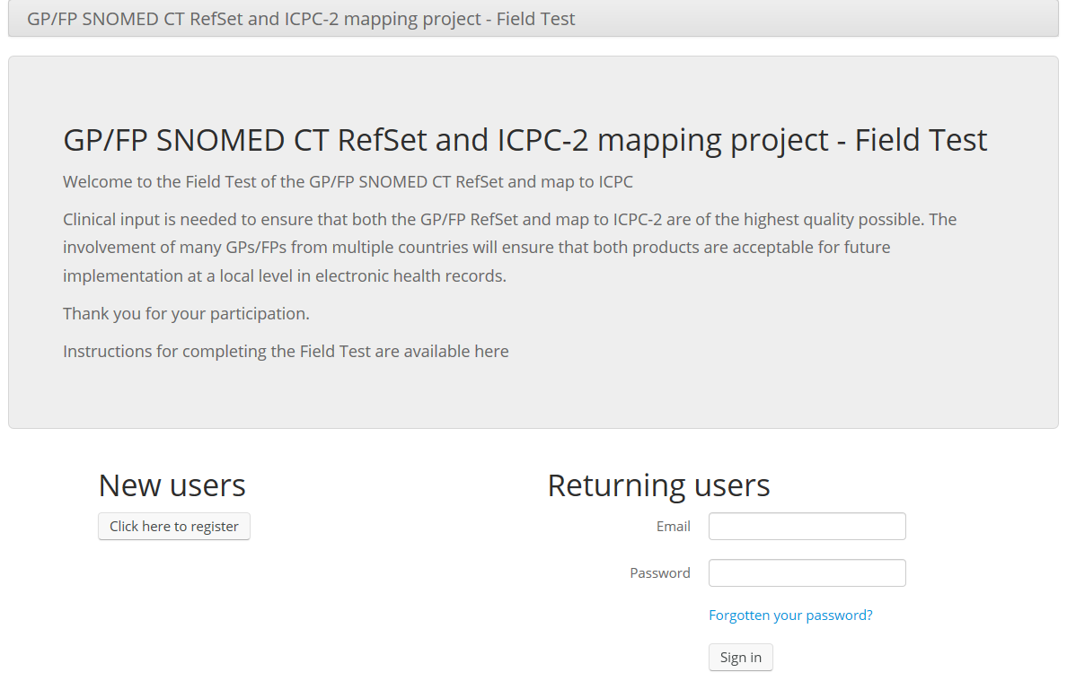

On subsequent occasions, you will need to open your preferred internet browser and go to http://fieldtest.snomedtools.com and log in by entering your email address and password.

If you forget your password, click on 'Forgotten your password?' and enter your email address. A temporary password will be emailed to you to allow you to access your account.

It is recommended that you bookmark the field test website as you are likely to access the field test website on several occasions.

9.2 Log out

Once you have finished entering encounters, you can log out by either clicking on your name in the top right corner and click 'Logout' or close the internet browser. Note that an encounter will not automatically save if you log out or close the internet browser while you are in the process of entering a RFE or HI.

You will need to log in next time you use the field test tool.

The web-based field test tool has a timeout period of 45 minutes, after which you will need to log in again to continue entering encounters.

1. Home page

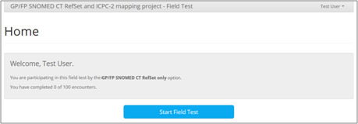

This is the home page. You can begin entering encounters by clicking on 'Start Field Test'.

If you have are a returning user, the home page will show you the number of completed encounters. You will have the option to enter a new encounter by clicking 'Resume Field Test' or review/edit existing encounters by clicking 'View Patient Encounters'.

You can return to this home page during the field test by clicking on your name in the top right corner and clicking on 'Home'.

1. Encounters

In the context of this project, an encounter is defined as any professional interchange between a patient and a GP (*Wonca Dictionary of General/Family Practice, 2003*).

Each participant is asked to assess the GP/FP RefSet by using RefSet concepts to record the RFEs and HIs from 100 encounters. The data may be entered during encounters, or entered by the GP/FP after the encounter has been completed. The encounters should be consecutive if possible, however this is not vital. It is likely that participants will need to use the web-based field test tool on several occasions to reach 100 encounters.

Participants are asked to use the RefSet to enter all reasons for encounter and health issues at each encounter. At least one RFE and one HI will need to be entered for each encounter. There is no limit on the number of RFEs or HIs entered per encounter. The RFE and HI can be the same concept with the same rating.

1. Reason for Encounter (RFE)

A reason for encounter (RFE) is defined as 'an agreed statement of the reason(s) why a person enters the health care system, representing the demand for care by that person. The terms written down and later classified by the provider clarify the reason for encounter and consequently the patient’s demand for care without interpreting it in the form of a diagnosis. The reason for encounter should be recognised by the patient as an acceptable description of the demand for care' (*Wonca Dictionary of General/Family Practice, 2003*). This is a similar though not precisely identical concept to presenting complaint, and is expressed using the patient's words.

1. Health Issue (HI)

A health issue (HI) is defined as 'an issue related to the health of a subject of care, as identified or stated by a specific health care party' (*Health informatics – System of concepts to support continuity of care – Part 1: basic concepts (CEN 13940-1)*). This can be further defined as corresponding to a health problem, a disease or an illness.

1. Field test of GP/FP RefSet only

14.1 Add Reason for Encounter

Enter a term to search for a RefSet concept that represents the RFE you want to record. More than one word can be entered however it is suggested that short keywords are used to broaden the search. Word fragments (the first few characters that form part of a word) and abbreviations can also be used. Click on 'Search' or press enter after entering the term to begin the search.

SNOMED CT concepts in the GP/FP RefSet that contain the search term in either the preferred term or its synonyms will be returned in the list.

Scroll through the list and click on a concept to see synonyms of that concept. Once you select a concept it will be highlighted in blue and its concept ID number will appear in bold text below the search list. Synonyms for the selected concept will also appear.

Select the RefSet concept with the preferred term and synonyms that best represents the patient's RFE.

The 'Reset' button next to the search list clears all the fields and allows you start again by entering a different search term. Alternatively, you can click in the search field and type a different term to search again.

If your search returns no matches, check the spelling of the search term or try another search using a different term.

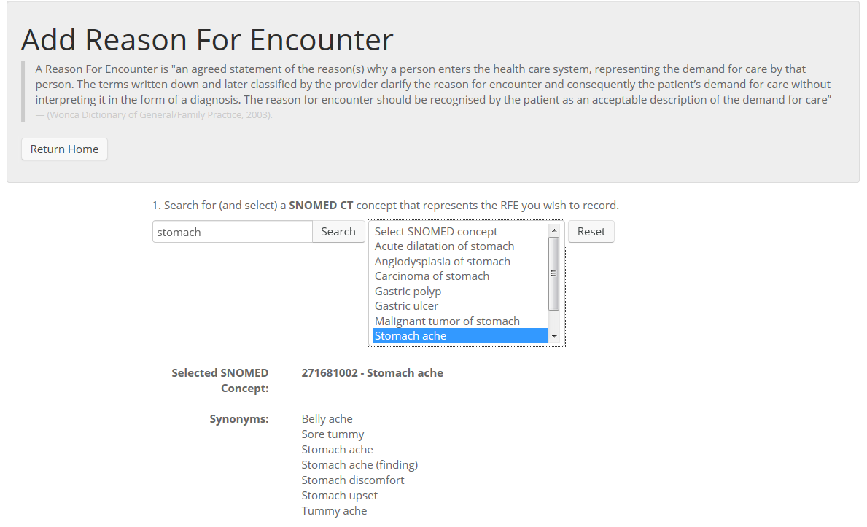

Example:

If you were trying to find a concept to represent the RFE of 'stomach pain', searching for the term 'stomach pain' will not return any matches. This does not necessarily mean that there are no concepts in the RefSet related to stomach pain. Try using a single search term or different terms to find similar concepts. Searching the term 'stomach' or 'stomach ache' will return the concept Stomach ache. Although stomach pain is not listed as a synonym of the concept Stomach ache, the terms are synonymous.

14.2 Rate appropriateness of the concept

After selecting a concept, rate how well the RefSet concept represents the RFE you want to record on a scale of 1 to 5 by clicking on the dot below the number (1 = Very well, 5 = Poorly). A rating must be given.

If the RefSet concept and its synonyms were not an accurate representation, give a rating and then enter the clinical term you want to record in the free text field.

If no appropriate RefSet concept was found, rate the match as a 5 and enter the clinical term you want to record in the free text field.

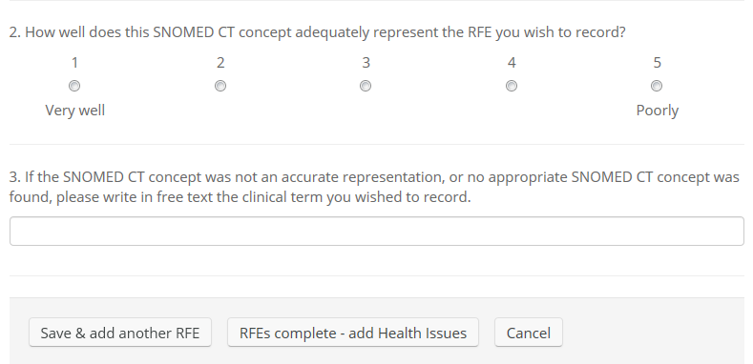

You can then either:

- 'Save & add another RFE'

- 'RFE complete - add Health Issues'

- 'Cancel' to delete this RFE and start again.

14.3 Add Health Issue

Using the same method as entering a RFE, search and select a RefSet concept that best represents the HI you want to record.

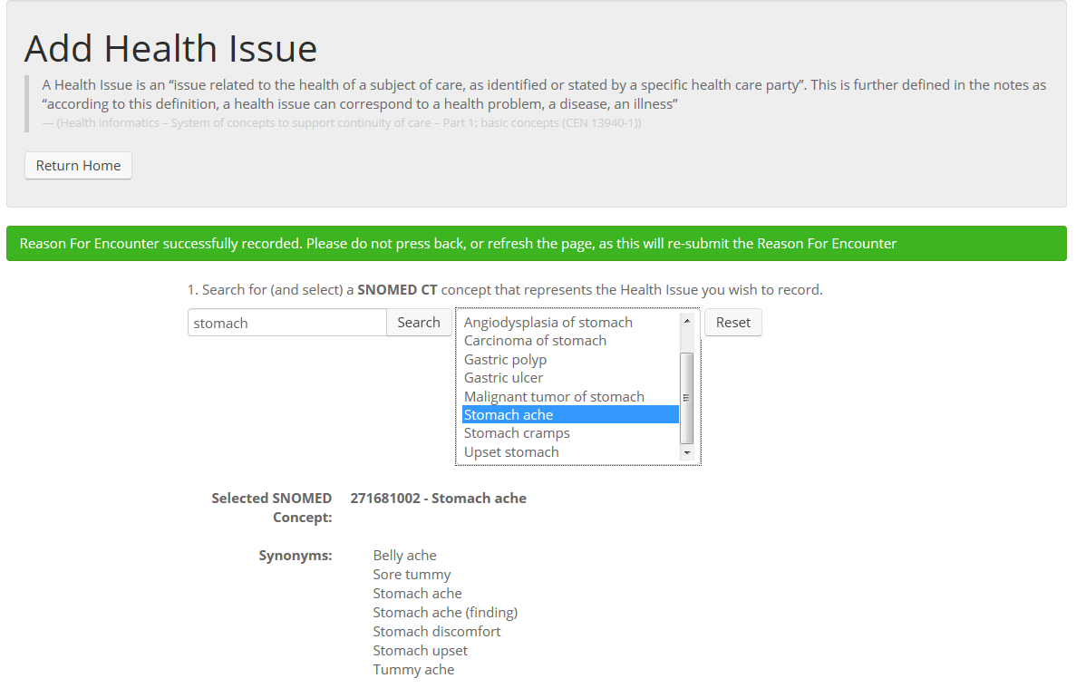

14.4 Rate appropriateness of the concept

After selecting a concept, rate how well the RefSet concept represents the HI you want to record on a scale of 1 to 5 by clicking on the dot below the number (1 = Very well, 5 = Poorly). A rating must be given.

If the RefSet concept and its synonyms were not an accurate representation, give a rating and then enter the clinical term you want to record in the free text field.

If no appropriate RefSet concept was found, rate the match as a 5 and enter the clinical term you want to record in the free text field.

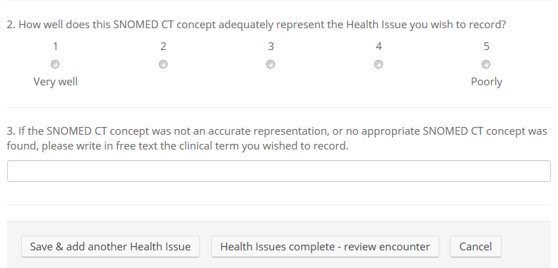

You can then either:

- 'Save & add another Health Issue'

- 'Health Issues complete - review encounter'

- 'Cancel' to delete this health issue. This will take you to the 'Home' page where you have the option to 'Resume unfinished encounter' or view existing patient encounters.

Selecting 'Resume unfinished encounter' will take you to the 'Review encounter' page where you can add another RFE, add a HI, delete this encounter or complete the encounter.

1. Field test of GP/FP RefSet and map to ICPC-2

15.1 Add Reason for Encounter

Enter a term to search for a RefSet concept that represents the RFE you want to record. More than one word can be entered however it is suggested that short keywords are used to broaden the search. Word fragments (the first few characters that form part of a word) and abbreviations can also be used. Click on 'Search' or press enter after entering the term to begin the search.

SNOMED CT concepts in the GP/FP RefSet that contain the search term in either the preferred term or in its synonyms will be returned in the list.

Scroll through the list and click on a concept to see synonyms of that concept. Once you select a concept it will be highlighted in blue and its concept ID number will appear in bold text below the search list. Synonyms for the selected concept will also appear.

Select the RefSet concept with the preferred term and synonyms that best represents the patient's RFE.

The 'Reset' button next to the search list clears all the fields and allows you start again by entering a different search term. Alternatively, you can click in the search field and type a different term to search again.

If your search returns no matches, check the spelling of the search term or try another search using a different term.

Example:

If you were trying to find a concept to represent the RFE of 'stomach pain', searching for the term 'stomach pain' will not return any matches. This does not necessarily mean that there are no concepts in the RefSet related to stomach pain. Try using a single search term or different terms to find similar concepts. Searching the term 'stomach' or 'stomach ache' will return the concept Stomach ache. Although stomach pain is not listed as a synonym of the concept Stomach ache, the terms are synonymous.



15.2 Rate appropriateness of the concept

After selecting a concept, rate how well the RefSet concept represents the RFE you want to record on a scale of 1 to 5 by clicking on the dot below the number (1 = Very well, 5 = Poorly). A rating must be given.

If the RefSet concept and its synonyms were not an accurate representation, give a rating and then enter the clinical term you want to record in free text.

If no appropriate RefSet concept was found, rate the match as a 5 and enter the clinical term you want to record in free text.

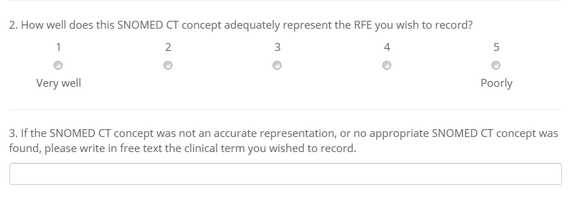

15.3 Select and rate the map to ICPC-2

You will then be asked to select and rate the ICPC-2 code that the concept is mapped to. Most RefSet concepts will only have one map to ICPC-2 and therefore only one ICPC-2 code will be available for selection in the box. If there is more than one ICPC-2 code listed, this indicates that there are conditional maps for this concept. For example, the map to ICPC-2 may differ based on the sex or age of the patient. Select the ICPC-2 code that you feel is the most appropriate match for the RefSet concept selected to represent the RFE. If there is only one ICPC-2 code listed you will still need to click on the ICPC-2 code to proceed.

15.4 Appropriate map to ICPC-2

If you are satisfied with the ICPC-2 code the RefSet concept has been mapped to, click on the ICPC-2 code to select it. The selected ICPC-2 code will be highlighted in blue and will also appear in bold text. Rate how well you think that the ICPC-2 code matches the RefSet concept you have selected to represent the RFE (1= very well and 5= not at all). A rating must be given. You can then either 'Save & add another RFE' or enter the HI subsequently managed by clicking 'RFEs complete - add Health Issues'.

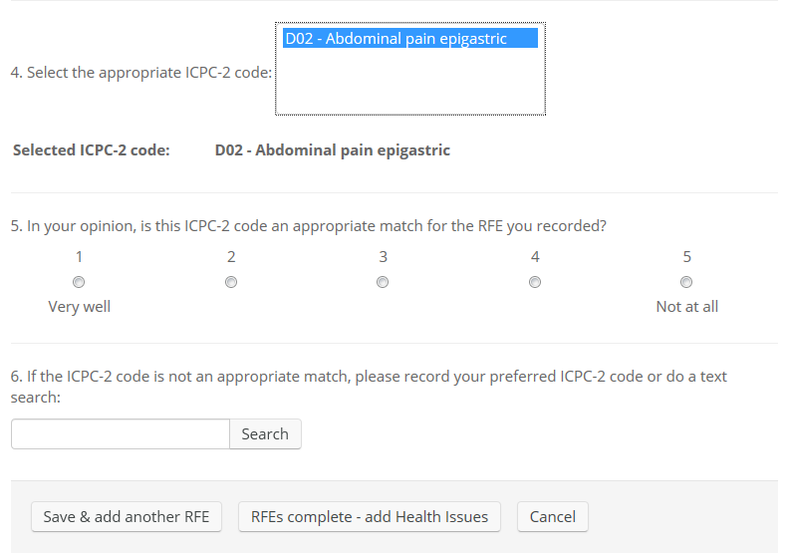

15.5 Inappropriate map to ICPC-2

If you feel that the map to ICPC-2 is not an appropriate match for the RefSet concept you selected to represent the RFE, rate the appropriateness of the match. Then search for and select your preferred ICPC-2 code by entering the ICPC-2 code directly or do a text search.

ICPC-2 codes are 3 character codes with one alphabetical character followed by two numbers (For example, A99). More than one keyword can be entered and word fragments (the first few characters that form part of a word) can be used however it is suggested that short keywords are used to broaden the search. Abbreviations cannot be used to search for ICPC-2 rubrics.

When searching for a process code, do not enter the alphabetic chapter code. For example, enter 31 rather than W31. It is recommended that you use a search term rather than ICPC-2 codes.

Click on 'Search' or press enter after entering the term to begin the search. ICPC-2 codes that contain the search term in the rubric label will be returned in the list.

Once your preferred ICPC-2 code has been selected it will be highlighted in blue and also appear in bold text.

If you find that after searching through ICPC-2 there is no ICPC-2 code that better represents the RFE than the one it has been mapped to, rate the appropriateness of the match and leave the ICPC-2 search field empty by clearing the search field and press enter.

You can then either click:

- 'Save & add another RFE'

- 'RFE complete - add Health Issues'

- 'Cancel' to delete this RFE and start again.

A red warning message will appear next to a required field if it has not been completed. You will need to complete all required fields before continuing.

15.6 Add Health Issue

Using the same method as entering a RFE, search and select a RefSet concept that best represents the HI you want to record. The same concept can be used to represent both the RFE and HI.



15.7 Rate appropriateness of the concept

After selecting a concept, rate how well the RefSet concept represents the HI you want to record on a scale of 1 to 5 by clicking on the dot below the number (1 = Very well, 5 = Poorly). A rating must be given.

If the RefSet concept and its synonyms were not an accurate representation, give a rating and then enter the clinical term you want to record in the free text field.

If no appropriate RefSet concept was found, rate the match as a 5 and enter the clinical term you want to record in the free text field.

15.8 Select and rate the map to ICPC-2

You will then be asked to select and rate the ICPC-2 code that the concept is mapped to. In most cases a RefSet concept will only have one map and therefore only one ICPC-2 code will be available for selection in the box. If there is more than one ICPC-2 code in the box, this indicates that there is a conditional map for this concept. For example, the map to ICPC-2 may differ based on the sex or age of the patient. Select the ICPC-2 code that you feel is the most appropriate match for the RefSet concept selected to represent the RFE. If there is only one ICPC-2 code listed you will still need to click on the ICPC-2 code to proceed.

Select the ICPC-2 code that you feel is the most appropriate match for the RefSet concept you selected to represent the HI.

15.9 Appropriate map to ICPC-2

If you are satisfied with the ICPC-2 code the RefSet concept has been mapped to, click on the ICPC-2 code to select it. The selected ICPC-2 code will be highlighted in blue and will appear in bold text. Rate how well you think the ICPC-2 code matches the RefSet concept you have selected to represent the HI (1= very well and 5= not at all). A rating must be given.

You can then either 'Save & add another Health Issue' or finalise the encounter by clicking 'Health Issues complete - review encounter'.

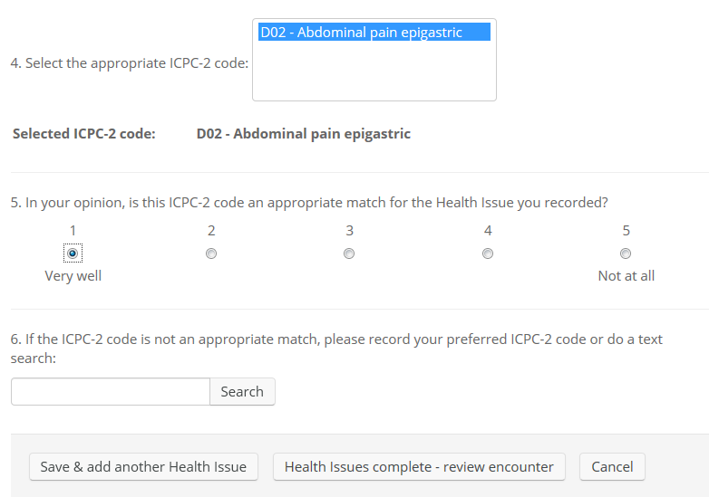

15.10 Inappropriate map to ICPC-2

If you feel that the map to ICPC-2 is not an appropriate match for the RefSet concept you selected, rate the appropriateness of the match. Then search for and select your preferred ICPC-2 code by entering the ICPC-2 code directly or do a text search.

ICPC-2 codes are 3 character codes with one alphabetical character followed by two numbers. For example, A99. More than one keyword can be entered and word fragments (the first few characters that form part of a word) can be used however it is suggested that short keywords are used to broaden the search. Abbreviations cannot be used to search for ICPC-2 rubrics.

When searching for a process code, do not enter the alphabetic chapter code. For example, only enter 31 rather than W31. It is recommended that you use a search term rather than ICPC-2 codes.

Click on 'Search' or press enter after entering the term to begin the search. ICPC-2 codes that contain the search term in the rubric label will be returned in the list.

Once your preferred ICPC-2 code has been selected it will be highlighted in blue and also appear in bold text below the search field.

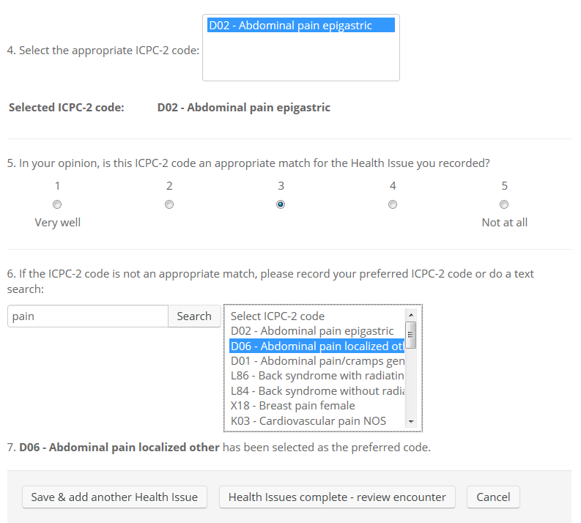

If you find that after searching through ICPC-2 there is no ICPC-2 code that better represents the RFE than the one it has been mapped to, rate the appropriateness of the match and leave the ICPC-2 search field empty by clearing the search field and press enter.

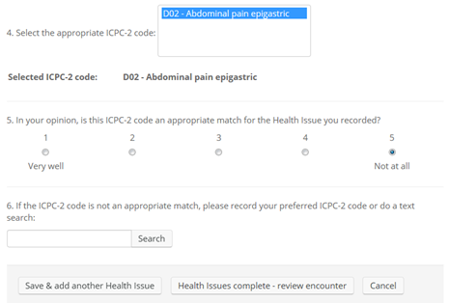

You can then either:

- 'Save & add another Health Issue'

- 'Health Issues complete - review encounter'

- 'Cancel' to delete this health issue. This will take you to the 'Home' page where you have the option to 'Resume unfinished encounter' or view existing patient encounters.

Selecting 'Resume unfinished encounter' will take you to the 'Review encounter' page where you can add another RFE, add a HI, delete this encounter or complete the encounter.

A red warning message will appear next to a required field if it has not been completed. You will need to complete all required fields before continuing.

1. Field test of ICPC-2 map to GP/FP RefSet

16.1 Add Reason for Encounter

Search for and select an ICPC-2 code that represents the RFE you want to record. ICPC-2 codes are 3 character codes with one alphabetical character followed by two numbers. For example, A99.

You can enter an ICPC-2 code directly or enter a term to search for an ICPC-2 code. More than one keyword can be entered and word fragments (the first few characters that form part of a word) can be used however it is suggested that short keywords are used to broaden the search. Abbreviations cannot be used to search for ICPC-2 rubrics. Click on 'Search' or press enter after entering the term to begin the search. ICPC-2 codes that contain the search term in the rubric label will be returned in the list.

When searching for a process code, do not enter the alphabetic chapter code. For example, only enter 31 rather than W31. It is recommended that you use a search term rather than ICPC-2 codes.

The 'Reset' button next to the search list clears all the fields and allows you start again by entering a different search term. Alternatively, you can click in the search field and type a different term to search again.

If your search returns no matches, check the spelling of the search term or try another search using a different term.

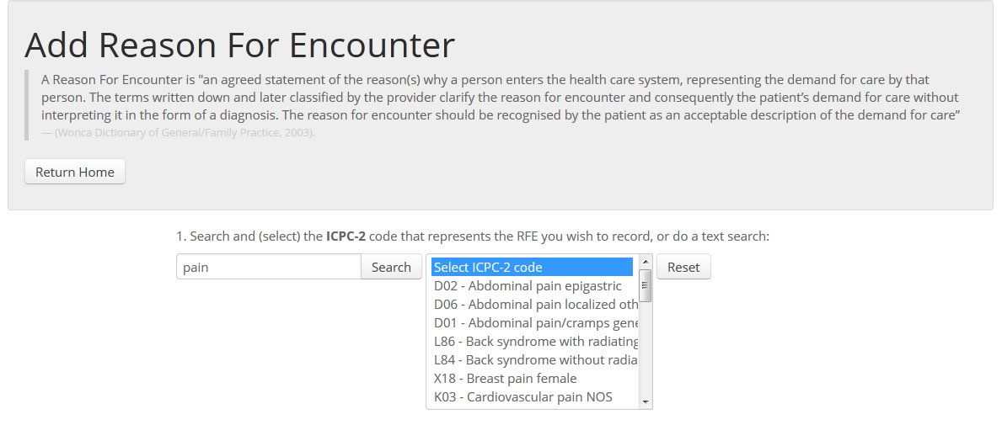

Users need to keep in mind when searching for an ICPC-2 code to represent a RFE or HI that ICPC-2 is a classification and does not contain the same level of specificity as a terminology like SNOMED CT.

Example:

If you were trying to find an ICPC-2 rubric to represent the RFE of 'stomach pain', searching for the term 'stomach pain' will not return any matches. This does not necessarily mean that there is no ICPC-2 rubric related to stomach pain. Try using a single search term or word fragment to find a rubric in the digestive chapter. Searching the term 'pain' will return a list of ICPC-2 rubrics related to pain. Scroll through the list and select the most appropriate ICPC-2 rubric to represent stomach pain.

Scroll through the list and click on an ICPC-2 code to select it. Once you select a code it will be highlighted in blue and it will appear in bold text below the search list. The map from the selected ICPC-2 rubric to RefSet concepts in the GP/FP RefSet will also appear.

Click on an associated RefSet concept to select it and view its synonyms. Select the RefSet concept with the preferred term and synonyms that best represents the patient's RFE. Each ICPC-2 code has a different list of associated RefSet concepts. One ICPC-2 code and one RefSet concept must be selected.

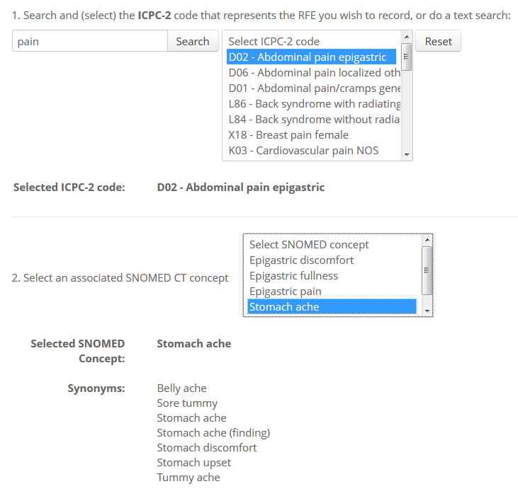

16.2 Rate appropriateness of the concept

After selecting a concept, rate how well the RefSet concept represents the RFE you want to record on a scale of 1 to 5 by clicking on the dot below the number (1 = Very well, 5 = Poorly). A rating must be given.

If the RefSet concept and its synonyms were not an accurate representation, give a rating and then enter the clinical term you want to record in free text.

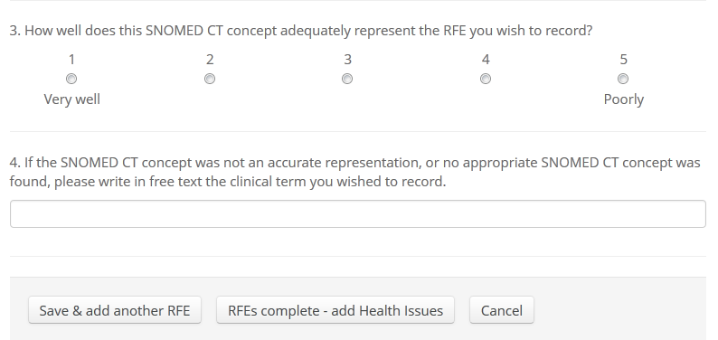

Example:

If you selected the ICPC-2 rubric 'D01 - Abdominal pain/cramps general' rather than 'D02 - Abdominal pain epigastric' to represent the RFE of 'stomach ache' a different list of associated RefSet concepts would appear to the list pictured above. The concept 'Stomach ache' would not appear in that list because it was not mapped to the ICPC-2 code D01. You should select the most appropriate SNOMED CT in the list pictured below, rate the appropriateness of the match and then enter the clinical term 'stomach ache' in free text. This indicates that you feel the clinical term 'stomach ache' should be mapped to the ICPC-2 code D01 rather than D02.

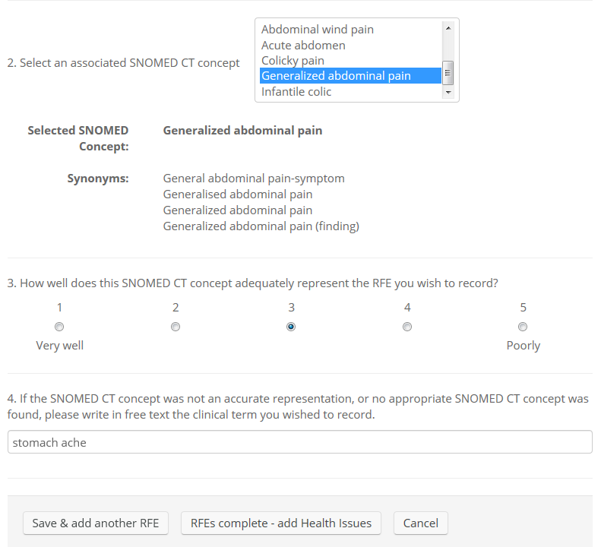

You can then either click:

- 'Save & add another RFE'

- 'RFE complete - add Health Issues'

- 'Cancel' to delete this RFE and start again.

A red warning message will appear next to a required field if it has not been completed. You will need to complete all required fields before continuing.

16.3 Add Health Issue

Using the same method as entering a RFE, select the ICPC-2 code that best represents the HI you want to record. The same ICPC-2 code can be selected to represent both the RFE and HI.

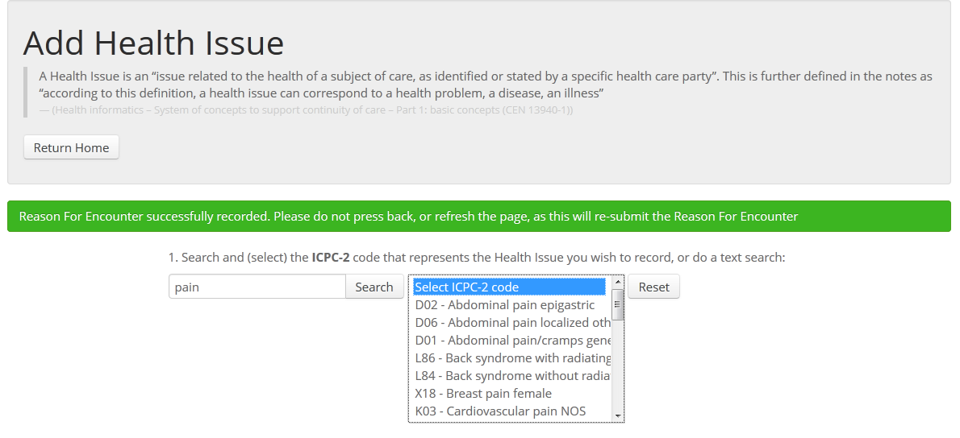

Click on an associated RefSet concept to select it and view its synonyms. Select the concept that best represents the RFE you want to record. Each ICPC-2 code has a different list of associated RefSet concepts. One ICPC-2 code and one RefSet concept must be selected.

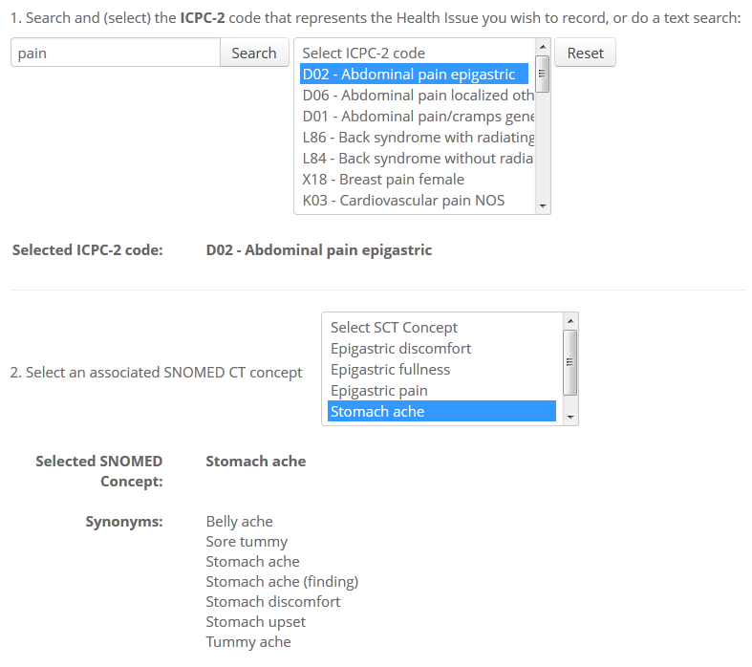

16.4 Rate appropriateness of the concept

After selecting a concept, rate how well the RefSet concept represents the HI you want to record on a scale of 1 to 5 by clicking on the dot below the number (1 = Very well, 5 = Poorly). A rating must be given.

If the RefSet concept and its synonyms were not an accurate representation, give a rating and then enter the clinical term you want to record in free text.

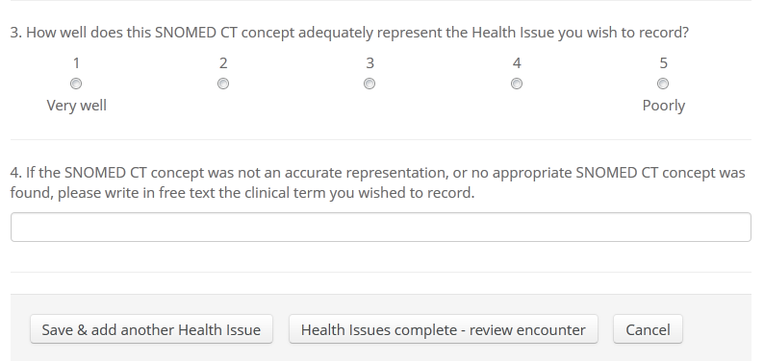

You can then either:

- 'Save & add another Health Issue'

- 'Health Issues complete - review encounter'

- 'Cancel' to delete this health issue. This will take you to the 'Home' page where you have the option to 'Resume unfinished encounter' or view existing patient encounters.

Selecting 'Resume unfinished encounter' will take you to the 'Review encounter' page where you can add another RFE, add a HI, delete this encounter or complete the encounter.

A red warning message will appear next to a required field if it has not been completed. You will need to complete all required fields before continuing.

1. Review encounters

You can review encounters that you have already entered at any time. However if you are in the process of entering a RFE or HI, changes are not saved until you have completed the encounter.

To review existing encounters click on your name in the top right hand corner of the webpage and click 'Encounters'.

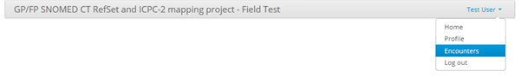

All existing encounters will be listed. To see details of a specific encounter, click on it. The RFE(s) and HI(s) entered for that encounter will be displayed.

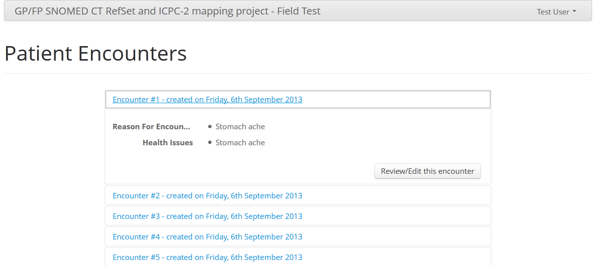

You can review the encounter in more detail or edit the encounter by clicking 'Review/Edit encounter' (shown in the screenshot above). This will take you to the 'Review encounter' webpage.

Clicking on a RFE or HI within the encounter will expand that RFE/HI to show the RefSet concept selected, the rating given and the alternative description of the clinical term (if entered in free text). Click on the RFE/HI again to hide the detail.

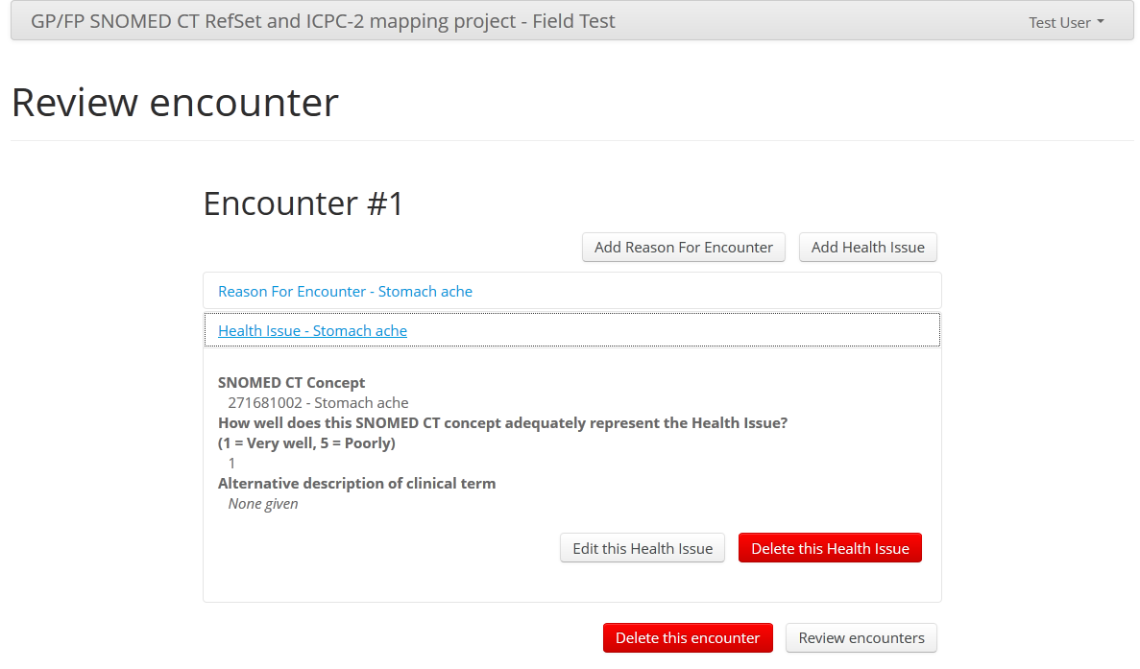

17.1 Editing an encounter

If you want to change the RefSet concept selected, change the rating or enter an alternative description of the clinical term, click on 'Edit this Health Issue' on the webpage shown above.

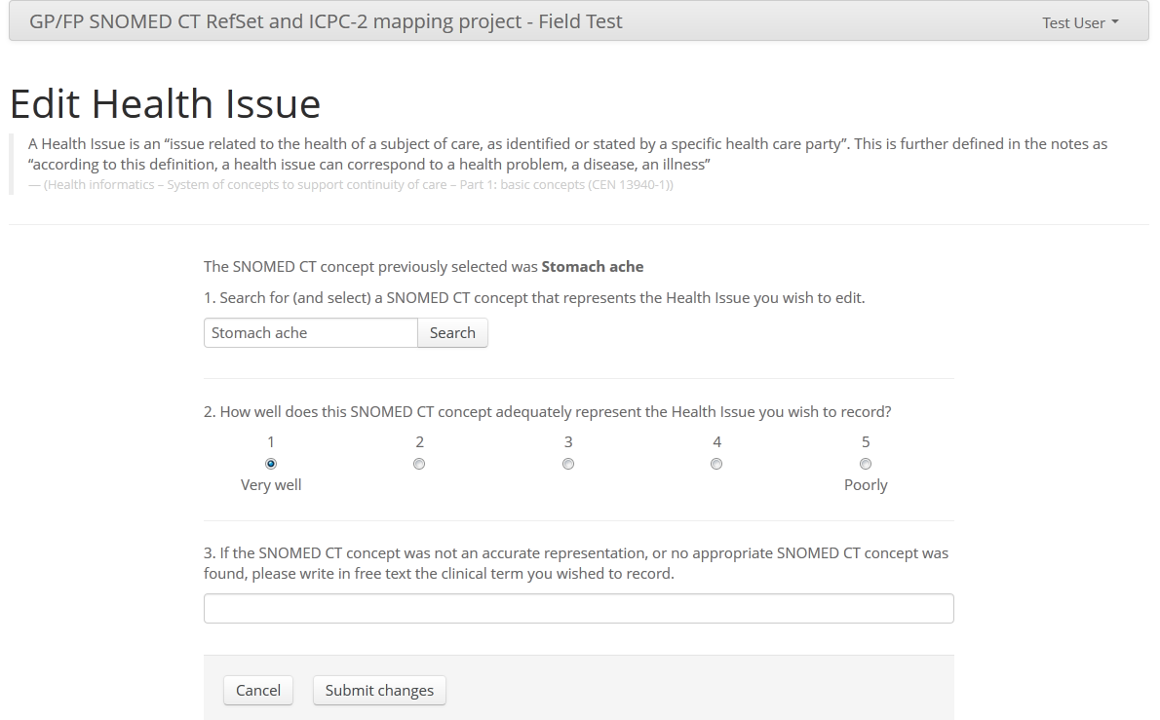

The concept that you previously selected to represent the HI will be displayed in bold. You can either search for and select a different RefSet concept, or if you cannot find a concept that better represents the HI than the original concept you selected, select the same concept again.

You can also change the rating of the match or alter the free text.

Click 'Submit changes' after editing.

1. Delete encounters

You can delete an existing encounter from the 'Review encounter' webpage.

1. Click on your name in the top right corner and click 'Encounters'.

2. Click on the encounter you want to delete.

3. Click 'Review/Edit this encounter' which takes you to the 'Review encounter' webpage.

4. Click 'Delete this encounter' and click 'OK' when asked to confirm that you want to delete this encounter.

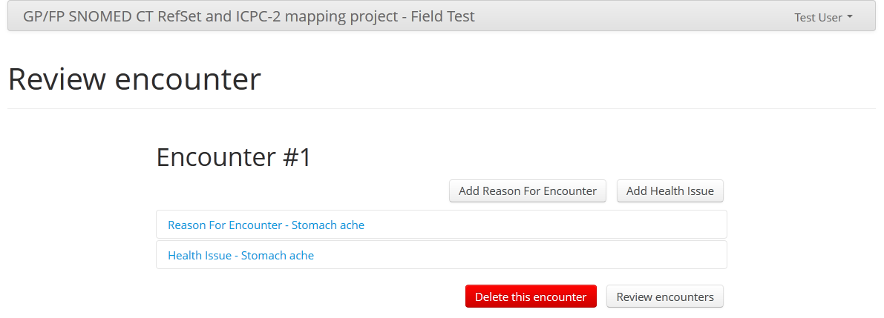

This encounter will be permanently deleted and the sequence number of the encounter will not be used again. So if you delete one encounter, in order to reach 100 encounters you should enter up to Encounter #101. The home page will tell you the number of encounters you have completed.

1. Submit encounters

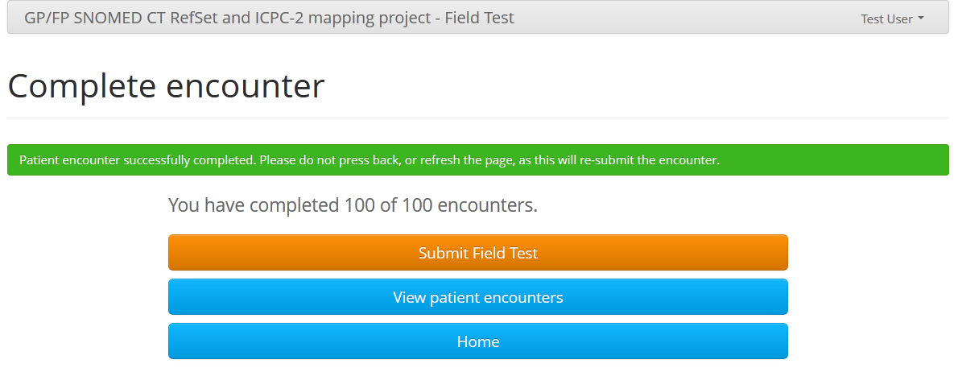

Once you have completed 100 encounters you will be asked to submit the field test. Click on 'View patient encounters' to edit any encounter before submitting the field test. You will be able to review patient encounters after you have submitted the field test but you will not be able to edit any information after submission.

The option to submit the field test will not be available if you complete fewer than 100 encounters. However the encounters you have entered will still be used as part of the field test.

All participants will receive a report about the field test on its completion.

1. Questions and feedback

If you would like to ask questions or provide feedback on the field test or the GP/FP RefSet and ICPC mapping project, please contact your local Project Group member or email the project manager, Julie O'Halloran (julie.ohalloran@sydney.edu.au).

A Google Group has also been set up for participants to ask questions and share feedback. You can access the Google Group by clicking [here](https://groups.google.com/forum/?hl=en#!forum/ihtsdo-wonca-field-test) or go to <groups.google.com>and search for 'GP/FP RefSet'. You will need to log in to your Google account before you can post a question.